

**YOUTH RISK BEHAVIOUR SURVEY**

**DATA ANALYSIS AND TRENDS REPORT**

**1991-2017**

**Report created by**

**Archana Ravi**

**EXECUTIVE SUMMARY**

The U.S. Youth Risk Behavior Survey (YRBS), conducted biannually since 1991, provides national data on the health-risk behaviors of all grade students. The Youth Risk Behavior Surveillance System (YRBSS) monitors six categories of health-related behaviors that contribute to the leading causes of death and disability among youth and adults, including—

* Behaviors that contribute to unintentional injuries and violence
* Sexual behaviors related to unintended pregnancy and sexually transmitted diseases, including HIV infection
* Alcohol and other drug use
* Tobacco use
* Unhealthy dietary behaviors
* Inadequate physical activity

YRBSS also measures the prevalence of obesity and asthma and other health-related behaviors plus sexual identity and sex of sexual contacts.

YRBSS includes a national school-based survey conducted by CDC and state, territorial, tribal, and local surveys conducted by state, territorial, and local education and health agencies and tribal governments.



**HOW TRAUMA IS A GATEWAY TO DRUG USAGE AND ALCOHOL INTAKE?**

The things you experience in your childhood typically follow you into adolescence and adulthood. They shape how you think, behave and react to people and situations. There is a clear connection between childhood trauma and alcoholism and other addictions.

Trauma can create a variety of long-term mental health issues, including PTSD. These issues lead many to self-medicate with excessive drinking or drug misuse.

According to the Children’s Mental Health Network(CMHN), the linkage between ACE’s and trauma and substance abuse disorders (SUD’s) is compelling.In his paper, Origins of Addiction, Felitti reports that people who experience 4 or more ACE’s are 500% more likely to abuse alcohol. People who report five ACE’s or more are 7 to 10 times more likely to report illicit drug abuse. A jaw-dropping data point indicates that individuals who survive 6 or more ACE’s are 46 times more likely to be IV drug abusers than people who report no ACE’s. Trauma truly is the “gateway drug” to addictions.

**TRENDS RELATED TO SUICIDAL RATES**

This analysis helps us find the trend of Suicidal rates from 2009-2017 :

* There is nearly 4.5% increase the percentage of respondents who claims to have attempted a suicide.

|  |  |  |  |
| --- | --- | --- | --- |
| **Have you attempted suicide?** | **Students who responded a ‘Yes’** | **Percentage of respondents** | **Total No of Respondents** |
| **Survey year** |  |  |  |
| **2009** | 1871.0 | 11.5% | 16188.0 |
| **2017** | 2024.0 | 16.2% | 14492.0 |

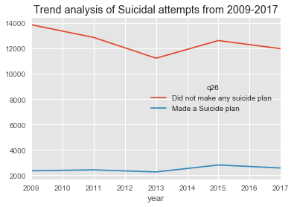

**TRENDS RELATED TO DEPRESSION**

The trends related to depression were inferred from the survey on how often they feel sad or hopeless in a day.

* The study proves that there is nearly a 4% increase in the number of students feeling sad or hopeless every single day.
* In 2009, nearly 1 in 4 students felt sad and hopeless.
* In 2017, nearly **1 in 3 students felt sad and hopeless**.

|  |  |  |
| --- | --- | --- |
| **Year of survey** | **Did not feel sad or hopeless** | **Felt Sad and Hopeless** |
| **2009** | **72.1%** | **27.8%** |
| **2017** | **68%** | **31%** |

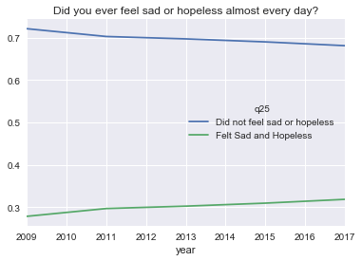

**TRENDS RELATED TO DRUG ABUSE**

* In 2009, nearly 1 in 4 students tried marijuana.
* In 2017, **almost 1 in 3 students have tried marijuana**.
* There is nearly a 5% increase in students who use Marijuana for the past 9 years.

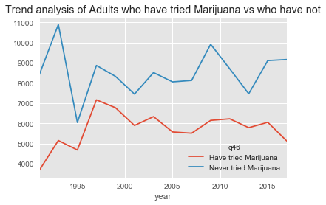

**DO MALE OR FEMALE USE MARIJUANA MORE?**

|  |  |  |  |
| --- | --- | --- | --- |
|  | **Have you tried marijuana?** | **No** | **Yes** |
| **Year of Survey** | **Sex** |  |  |
| **1991** | **Male** | **73.5%** | **26.4%** |
| **Female** | **65.4%** | **34.5%** |
| **2017** | **Male** | **63.6%** | **36.3%** |
| **Female** | **64.7%** | **35.2%** |

**BIBLIOGRAPHY**

-Data Reference :<https://www.cdc.gov/healthyyouth/data/yrbs/data.htm>

Others References:

-<https://www.gatewayfoundation.org/addiction-blog/trauma-and-addiction/>

-<https://www.cmhnetwork.org/news/trauma-is-the-gateway-drug-an-aces-informed-approach-to-substance-abuse-treatment/>

-<https://sobernation.com/the-correlation-between-trauma-and-substance-abuse/>